Smells like Teen Sprit

How Does P!nk Investigate Gender Identity In Her Work?

Aaron Chivers

I declare that I have not plagiarised another’s work and that all material and quotes are referenced correctly.
When evaluating the singer P!nks imagery and how she investigates gender identity, it will be useful to look at Feminist and Post-feminist debates and theories along with subcultural theories. The use of subcultural ideologies and feminist theory show how the lines between the genders are blurred in P!nks work. Also the use of fashion and make-up with its historical references will support the ideas being conveyed about how P!nk blurs the genders as a feminist.

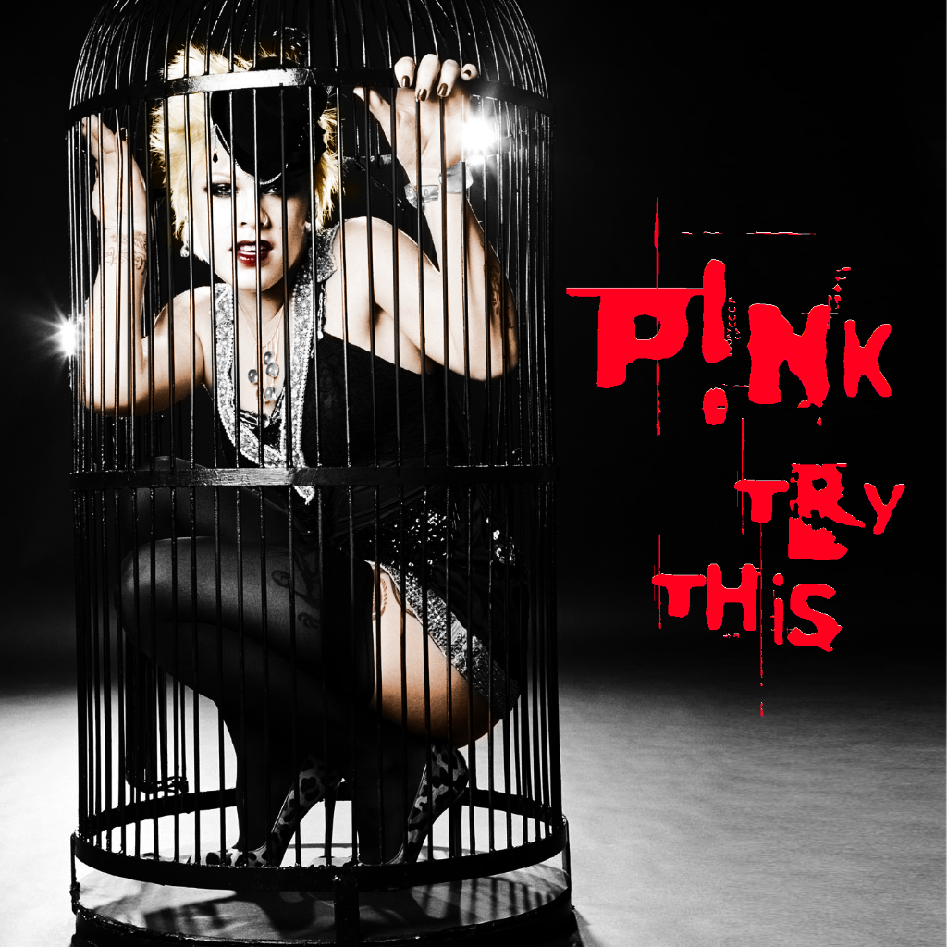
Case Study 1

This first case study explores the use of gender identity in the singer P!nk’s cover art from the Try This album released 2008.
When analyzing this image attention was immediately drawn to P!nk’s hairstyle. The style is unconventional to a main stream or parent culture, its artificial bleach blond colouring is unnatural and presents hints of a Goth culture.
“Unnatural colour hair common in both subcultures, the Goth’s prefer black and stark white.” Ferecay(2001)
The unnatural colouring in connection with Goth subculture indicates the bluring of gender identities.
“There seems to be no correlation between hair styles and gender in the Goth world – hairstyles are accepted as not being restricted by either sex or gender” Ibid
P!nk continues to use the ideologies from the Goth subculture in the form of makeup, the first of which is the pale parlour. P!nk employs a pale foundation to remove the healthy colour from her face to create a blank dealth like look.
“...white foundation is use to wipe away any trace of colour from the face, giving the Goth the appearance of death...” Ibid
However the pale parlour has strong connections with Victorian style makeup.
“The ideal Victorian look was to have pale unblemished skin.” Lou (2013)
In addition to the pale skin tone P!nk reinforces the Goth style with heavy eyeliner and eye shadow. The clearly defined use of eyeliner and heavy eye shadow creates a sunken look accentuating the impression of death.
“The eyes are usually accentuated with the use (or over use) of black eyeliner and dark eye shadow, intensifying the sunken deathly look.” Ferecay (2001)
Black eye shadow was popular in Victorian Britain with the excessive use associated with unvirtuous and lose women.
“Eye shadow was popular too, with black and red being the most common colours. Only disreputable ladies though would wear it on the whole lid” Lou (2013)
Along with the eye shadow P!nk is also styling deep red lipstick this is typically associated with prostitutes.
“By the 1700s, social and legal penalties ensured that the use of lipstick was kept to a minimum in England, and only prostitutes were bright makeup. Williams (2011)
Not only is the red lipstick associated with Victorian prostitutes it has also been used in many cases to exaggerate the deathly look of the Goths.
“Black or very dark crimson lipstick is used to heighten the impact of the deathly parlour” Fereday (2001)
When observing the costume it is clear to see P!nk combines a variety of elements to create an interesting aesthetic full of meaning. The top hat was created as men’s wear and has typically been a male symbol.
“The top hat was born in the 1790’s and became the replacement headwear for men” Cheong (2011)
It has been transformed into a fascinator which is a female hare accessory.
“Traditionally a fascinator is warn on the right hand side of your head” Vale (2012)
P!nk has feminize the top hat,, this is called Bricolage.
“Bricolage refers to the way the meaning of a particular object or media text were transformed as they were accepted an recontextualized” Osgday (2004)
Continuing from the top hat, in the art work of the album cover P!nk is modelling a babydoll dress, which is a form of nightwear and negligee.
“a piece of lingerie usually it is always worn to bed and is a short nightgown or negligee” Ardiansyah (2012)
Similar to this Punk’s wear underwear or bondage gear outside the original context of their creation, underwear and bondage gear are normally kept behind close doors and out of public view. Punk’s and P!nk challenge this convention by wearing negligee as everyday clothing.
“In particular the illicit iconography of sexual fetishism was use to predicable effects. Rapist masks, and rubber wear, leather bodices an fishnet stocking, implausible pointed stiletto heeled shoes, the whole paraphernalia of bondage-the belts, straps and chains-were exhumed from the boudoir, closet and the pornographic film an placed were they retaine their forebidden connotations.” Hebdige (2007)
The babydoll dress itself is usually made of fabrics most commonly silks and chiffon.
“silk, chiffon or nylon is mainly the fabric for the babydoll dress, and it is usually sheer or see through” Ardiansyah (2012)
Silk on its own is a luxurious and opulent fabric.
“Silk fabrics embody luxury and elegance” NY Fashion Centre
To compliment the babydoll dress, in the image P!nk has on a pair of black stocking. Stockings have evolved from a non-gender specific garment to an almost exclusive female item of clothing.
“They were worn by both men and women until the long trousers became the choice de riguear for chaps in the 18th century.” Pearson (2013)
Stockings later became associated with eroticism, sex and sexual fantasies.
“Today stockings scream sex. As the late Victor Arans wrote,″ when a women takes off her clothes, she can be depicted as a pure classical nude, if however, she keeps her stockings on, she suddenly becomes naked, an erotic creation capable of arousing the views libido.” Pearson (2013)
Further more in the image P!nks entire ensemble is coloured in solid black broken with silver. Black is a powerful and terrifying colour, black connotates secrecy, intimidation and power, this compliments the image of p!nk showing herself as a powerful women.
“Black is intimidating, unfriendly and unapproachable because of the power is exudes” Scott-Kemmis
Also you can see the outfit is broken by flashed of silver. Silver suggests femininity from a near spiritual view point.
“The colour has a feminine energy, it is related to the moon” Scott-Kemmis
Silver can also be said to be associated with the glamorous and sophisticated.
“It is seen as glamorous, sophisticated colour, related to feminine energy.” Scott-Kemmis
At the foundation of P!nks outfit she is wearing leopard print stiletto heels. The stiletto as a name refers to a renaissance dagger, this reference also connotates danger.
“The stiletto heel- named after a slender Italian dagger of the renaissance” Paglia (2014)
The stiletto heel as well as being named after dangerous blade has its own social killer meaning, the stiletto can be viewed as a women’s metaphorical weapon.
“The stiletto high heel is modern women’s most lethal social weapon” Paglia (2014)
The heel also transforms women, giving the confidence.
“Timid, self-cautious women have transformed into sexy, bold confident divas” Aviles
The leopard print continues to suggest that it gives a women an animalistic quality of hunting and an allure.
“Women can use it to catch her prey, which is a man, and men are not complaining. Men find the style sexy and provocative.” Aviles
Finally the use of the stilettos sexually transforms a women’s natural body into an invitation for sex.
“forcing breasts and buttocks out in a classical hominid posture of sexual invitation” Paglia (2014)
Surrounding P!nk is a cage. The cage has many symbolic references to name a few entrapment, closure, oppression.
“[Oppression is] the experience of being caged in… consider the bird cage…” Bailey
Also related to a cage are feelings of both repression and oppression.
“Looking at a cage and that there are people who are caged, whose motions and mobility are restricted, whose lives are shaped and reduced.” Frye (1983)
Some of the people who have suffered as a result of being cadges are women, gays and lesbians.
“…we thus left with the impression that Wittig understands sex to be discursively produced and circulated by the system of significations oppressive to women, gays and lesbians.” Jackson, Pg 137
After looking at the image as a whole is it clear to see, when taking all the elements into account, P!nk uses feminism to her advantage, to express female power, strength and individuality. In this study it can be clearly seen that P!nk does not agree with the nineteenth century stereotype of women, she boldly objects and does not require a man to rescue her. P!nk is no way delicate, it is plain to see from the analysis of the image that P!nk is a strong independent women with no need for a hero.
“The dominating nineteenth century concept of women as fragile, delicate creatures requiring protection from chivalrous, virile men.” Jackson, Pg 133
Not only does P!nk use fashion and props to portray her messages, she also uses her body as a way of communicating her views. She shows her body in revealing cloths i.e- the babydoll dress, stockings and stiletto heels all having meaning that associate with sex. She uses her body to perform with her gender and showing women as strong powerful; creatures.
“Bodies become gender through the continual performance of gender” Jackson, Pg 137
P!nk also deconstructs women as the weaker sex and the reconstructs theme to her idea of a women.
“Butters perspective on sex and gender entails a view of women as a construct” Jackson, Pg 138
From what is found in this case study P!nk does conform to “Post-Feminist” theorise, as she uses her femininity and sexuality for her own to show her strength throughout her work, for her own advantages and gain.
“A post-feminist turn, as femininity and sexuality used for self-definition and self-gain.” Genz, Pg 123
The use of specific subcultural ideas in connection with feminism in P!nks work has created a strong statement the use of fashion and accessories, with traditional iconographies have allowed her to explore gender identity and challenge a male dominated society. The power of feminism shines through, strong and clear whilst using her physique and strength to punch out a proud, strong, fierce female message.

Case Study 2

The second case study continues to look at gender identity in P!nks work. This case study is based on the music video still from “U + UR HAND” a track from the “Im Not Dead” album released in April 2006.
One of the most noticeable things in the image is its location this being a garage. This garage is a typically male dominated environment, P!nk is challenging this by working in a man’s occupation.
“Challenging traditional male dominance of garages.” BBC News (2006)
This displays women as just as strong and as capable as men are- also showing that women can do the same job as a man with the same efficiency.
“Women are strong at identifying the cause of breakdowns.” BBC News (2006)
In keeping with the environment P!nk has had oil put on specific areas of her body this is in reference to stereotypical mechanics.
“Typical stereotype of beefy, oil stained men, hauling heavy car parts” BBC News (2006)
By showing a women in a man’s working environment P!nk is challenging the male ideologies of a women being dependent on a man.
“… De Beauvior points out, men define themselves as the exemplary case of humanity and they define women as dependant on men” McCann (2009)
It seems clear from P!nk showing herself working in a man’s stereotypical environment opposing sexism and women being less than men.
“Women must fight sexism constantly” McCann(2009)
In the still from “U+UR HAND” P!nk is styling a leather bolero jacket. The bolero is iconically female, and are associated with accentuating the waist and bust, but it is traditionally a males piece of clothing that P!nk has reinvented.
“A short jacket, coming barely to the waist worn by men in Spain, applied to garments worn by women” Burgess (2011)
The leather jacket indicates rebellion and bad boy ideologies, antisocial and law breaking views, the leather jacket also has connections with the Punk subculture.
“The adopted the leather jacket as a kind of social signifier that identified them as outside of the law, rebellion and the leather jackets were soon ineluctably intertwined: the Punk era of the 1970s erupted with anti-establishment sentiments” Ssence (2014)
In essence P!nk challenges and fights against the established views of women, challenging what gender is and challenges the boundaries of gender.
“Gender as socially constructed masculinity and femininity. Masculinity and femininity are defined not by biology but by social, cultural and psychological attributes which are acquired though becoming a man or a women” Jackson, Jones (2010)
As well as challenging and fighting the establishment which in and over itself screams Punk,
“It was in the performance area that Punk groups posed the clearest threat to law and order” Jackson, Jones (2010)
Also P!nk is using feminist values, throwing off the repressed position of women in a capitalist society.
“Women’s subordination as a consequence of capitalism and there who was it as a consequence of patriarchy of a system of male domination” Jackson, Jones (2010)
In addition to the bolero jacket P!nk is modelling leather underwear and pointed stiletto heeled boots. The main attraction of P!nks outfit is the underwear which connotates the underground fetish/bondage gear of the Punks, showing herself as dominate and not as submissive.
“Leather bodices and fishnet stockings, implausible pointed stiletto heeled shoes, the whole paraphernalia of bondage- the belts, straps, and chains- were exhumed from the boudoir, closet and pornographic film, and placed on the street where they retained their forbidden connotations” Hebdige (2007)
The overall style of P!nk as a Rocker girl has a deeply gothic connection, the style with in the “U+UR HAND” video emits the feeling of a strong powerful women, however, it has been found that the unhealthy look, poses and style are based around charatures from the comic book “White Trash” (You Thought We Wouldn’t Notice (2006) and the art by Martin Emounds.
“P!nk wearing clothing and posed as several of Emounds characters including, “BabyRedKnuckles”, “RockerBikerGirl” and “HardCandy” frequently involved fierce, muscular women with a gothic undead look” (You Thought We Wouldn’t Notice(2006)
In contrast to the overall look P!nks face is very pale this in relation to the gothic make-up.
“White foundation is used to wipe away any trace of colour from the face, giving the goth the appearance of death” Fereday
As well as the pale skin tone, P!nks eyes are in shocking contrast again this suggests ties with the gothic style of the undead.
“The eyes are usually accentuated with the use (or overuse) of black eyeliner and black eye shadow intensifying the sunken deathly look” Fereday
P!nks hair also displays the unnatural iconographies of gothic hairstyles.
“Unnatural coloured hair is common in both, the goths preferring black or stark white” Fereday
From what has been discovered in this case study of the above image (U+UR HAND video still) P!nk conforms to feminist theory. However, she does not follow Post-Feminist theory, she does not allow men to take over her world.
“…Post-Feminism appears as a Trojan horse pretending to expand the feminist debate but, in effect allowing male critics to enter and take over Feminism” Genz, Bradon (2009)
It Is clear to see P!nk stays strong and true to her message.

Overall, the development of gender identity though P!nks work is pretty clear, it is clear from one album to another. Subcultural theorise and Feminist theorise are useful in understanding how P!nk explores gender identity. In part the album art work from the “Try this” album shows a suppressed women, waiting to break free, this is supported with the studies on gender identity and feminist theories. P!nks aim is to show she has thrown off the restraints of a suppressive patriarchal society .
The change from a suppressed women to a free powerful women is bold and clear, with the ideologies of the Goth and the Punk subculture, P!nk blurs the boundaries of gender further by throwing the typical ideologies of men’s natural work environments to the wind. Punk and Goth subcultures blurred the boundaries from the 1970s, however, P!nk goes further still by using her own sexuality to fight her corner.
P!nk is a feminist and her work carries strong messages that she is just as strong as a man, however, there conflicting points about Post-Feminism, she does not allow men to take over her work, not even her manager, but on a counter point P!nk does use her sexuality as a means of empowerment. Gender identity with in P!nks work saturated with the underlying message of be who you want to be, break free of your ties. In the words of P!nk herself…
“Raise your glass if you are wrong,
In all the right ways” P!nk (2010)
Through the use of feminism and Subcultural references P!nk empowers people to be who they are regardless of their gender, class, sexuality. We are all equal.

