Does Alexander McQueen make the Grotesque Glamorous?

Aaron Chivers

I declare that I have not plagiarised another’s work and that all material and quotes are referenced correctly.

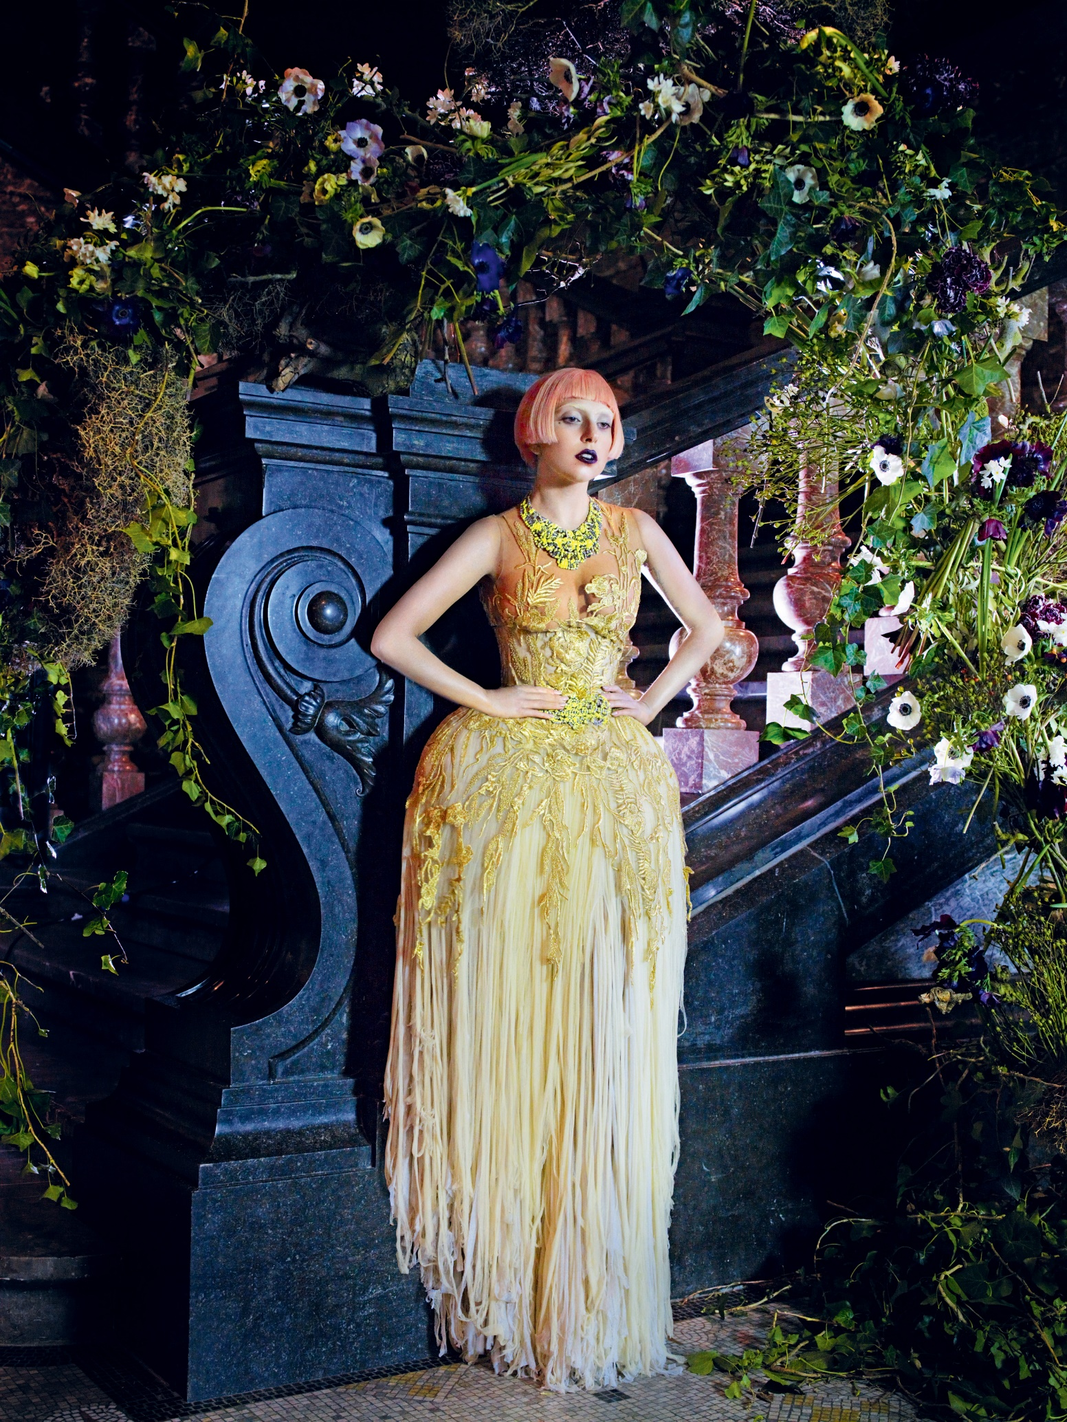

When analysing the image of Lady Gaga wearing a McQueen dress it is important to separate the two, Lady Gaga is known for being excentric in her style and fully supportive of people being who they feel they are without shame, however in this case study I am looking at how McQueen creates the beautiful from the grotesque.
When breaking down the image into its individual parts it is useful to start from the top. In the case of the Gaga McQueen image, the figure is the most prominent aspect and it is clear that there are ideologies of the glamorous throughout it. Gaga has been made up styling the iconic 1920s short hair style, the short cut defeminises Gaga giving her a boyish look, this refers to the 1920s erotic image of women.
“The new erotic was androgyne: girls stove to look as much like boys as possible… as if to give the crowning touch to their attempted boyishness all young women cut their hair” (Laver cited p33)
The eyes have been lightly shadowed giving the appearance of a slightly sunken and deathly look this is in opposition of the glamour’s notion of the hair. The sunken deathly look is iconic of the goths along with their obsession with a death like quality in there style, this death like look is representative of the grotesque.
“The eyes are usually accentuated with the use (or over use) of black eyeliner and dark eye shadow, intensifying the sunken deathly look” (Fereday, 2001, online)
The eyes are in striking contrast to the face, whilst the eyes are shadowed the face is stark white due to the make-up used. The make-up is used to hide the blemishes of aging, creating the smooth, polished look that is desired by the glamourous.
“If the polished surfaces of the conventional make-up and fashion can constitute a carapace to hold the horror of death and decay at bay.” (Evans, 2007, p227)
The dress has a whole different level to it, the bust is made from chiffon, which is sheer and reveals the skin underneath, and this is very similar to the babydoll dress in the fabrics and the ideologies of sexiness and male lust.
“Silk chiffon and nylon is mainly the fabric for the babydoll dress, and it is usually sheer and see through.” (Ardiansyah, 2012, online)
This style of dress however, whilst it uses luxurious and glamorous fabrics it does not however conform to the ideologies of the glamourous. The glamourous dress style would navigate the eyes away from the breasts and the hips, where and McQueen’s dress exaggerates the hips and bust.
“Primary among the elements of this metamorphosis was the elongation of the women’s neck, legs, and arms in advertising sketches…moved attention away from the female torso.” (Marchand, 1985 cited p73)
The corseted waist of the dress extenuates the hips, pulling in the waist revealing the shape of the figure with in. In McQueen’s case the over the top and excessively exaggerated child baring hips.
“The modernity of the art deco female body is tied to earlier changes in the corset and dress fashion spearheaded by the parison couturier Paul Poiret converted the corset from the S shaping vehicle it had been to one that flattened the hips and buttocks, liberating the waist…the effect was to shear the figure of women away from the previously accreted meanings- mother, womanhood, domestic angel.” (Winokur, cited p32)
The exaggerated hips and the accentuated breast all have connections with the Goddesses in Wicca and Paganism. The Goddesses being a liminal being and as the mother in her second phase.
“As Mother, she appears with the full moon. With a child in her belly, she safe guards the hearth of her people” (Summers, L 2006, p12)
One of the most extravagant aspects of this dress is the gold lace overlay, this is interesting from the point of view of its spiritual inspiration as in Wicca gold is a masculine metal and colour.
“ Gold-shining like the warm sun, Gold is a symbol of the God in general and the Sun God in particular, gold is a Yang metal.” (Dragonsong, E online)
Also the lace layover on the bodice looks as if it is meant to be suit of armour, the way it has been placed is similar to that of a breast plate, this is typical of McQueen dresses. McQueen believes in strong powerful women protected by a sense of style not a man.
“When you see a women wearing McQueen, theres a hardness to the cloths that makes her look powerful, it kind of fends people off.” (McQueen 2005)
Although this strength is juxtaposed against the natural delicate, luxurious and glamourous nature of silk.
“In the twentieth century fashion, glamour had its cliches, glitter, furs and slinky dresses, hot house flowers and a slash of bright red lips. Glamour was about luxury and excess. It spoke of power, sexuality and transgression. It could also be about pleasure, the fur, silk and rich fabrics.” (Dyhouse, C. (2010) Glamour: women, history, Feminism, p1-47)
As well as this the lace with this shredded effect and the way it cascades down the figure in a decaying unruly manor dose not conform to the notions of the glamourous, but it does for fill the attributes of the monster.
“It is the propensity of the monster to deconstruct at any time, to always be in that process of decomposition that makes it/him/her a fugitive from identity.”
The entire dress is in a state of change, changing from beautiful and glamourous to decay and unravel ment it is a liminal in its own right.
“….the vulnerabilities of our own embodied being. Monster, then are deeply disturbing…they are always liminal, refusing to stay in place, transgressive and transformative. They disrupt internal and external order…overturn the distinction that set out the limits of the human subject.” (Shildrick, 2002, p4)
The partly exposed breasts and large exaggerated hips, rich with the notions of child birth/ and child bearing connections with the mother aspect of the goddess.
“As mother, she appears with the full moon. With a child in her belly, she safe guards the hearth of her people” (Summer, L, 2006, p12)
The bottom of the dress is in state of decay and change; this is in relation to the Crone the last part of the cycle before it starts again.
“The Crone aspect of the goddess encompasses all that is wise, she is wielder of magic, the dark side of the moon; she’s not always benign. Of all aspects it is the Crone who walks closest to death and rebirth.” (Summer, L, 2006, p12)
The flowers surrounding the figure can also be said to carry connation’s of death and decay, because they look beautiful for a while but they will die. Decay as they only live so long after being cut.
“You may Pay top Dollar for the best Lilies and Roses, but, they will be dead with in 3 days if you don’t look after them” (Jones, R 2004 p7)
After looking at Alexander McQueen’s work it is clear that whilst he uses aspects of the glamorous he counteracts this by centring his work on the grotesque. In doing so he creates a fusion between the two, his clothing is not just about looking good, but the power that an outfit can install within the women wearing the article. While McQueen’s work has been viewed by some as none couture, the use of fabrics and iconography with in a piece lulls you to feel this fusion. McQueen forces the viewer to look at the grotesque as glamour in its own right. In the same way that a woman is a goddess in her own right. As powerful as nature herself, self-reliant, and unique.

Bibliography
Ardiansyah, R. (2012) History of the Babydoll Dress. [Online] September 13, 2012. Available from: http://fashion.rudiardiansyah.net/history-of-babydoll-dress/ [Accessed 26/11/14]
Barnard, M. (eds) (2007) Fashion Theory: A Reader, London: Routledge
Brown, J. (2009) Glamour in Six Dimensions: Modernism an d the Radiance of Form, Cornell University Press, New York.
Creed, B. (1993) The Monstrous Feminine: Film, Feminism, Psychoanalysis. London: Routledge
Dyhouse, C. (2010) Glamour; Women History, Feminism, Zed Book, London
Dragonsong, E [online] available from; www.wicca-spirituality.com/god-symbol.html , Common Wiccan God Symbols [Accessed on 20/08/14]
Evans, C. (2007) Fashion at the edge; Spectacle, modernity and deathliness/Caorline Evans (ed 2) Yale University Press
Fereday, A. (2001) Reading Goths the Birmingham Way. [Online] Available from: http://homepage.ntlworld.com/andrew.fereday/macs01.htm [Accessed 22/11/14]
Fisher, L. (2003) Designer Women, Cinema, Art deco and the Female Form, Colombia University Press
Halberstam, J. (1995) Skin Shows, Gothic Horror and the Technology of Monsters, Duke University Press, Durham
Jones, R. (2004) Caring for Cut Flowers (Ed 2) Landlints Press
NY Fashion Center (2010) Not all fabrics are created equal, Silk fabrics. [Online] Available from: http://www.nyfashioncenterfabrics.com/silk.html [Accessed 26/11/14]
Shildrick, M. (2002) Embodying the Monster, Encounters with the vulnerable self, Sage Publishers, London
Stallybass, P; White, A (1986) The Politics and Poetics of Transgression, Cornell University Press, New York
Summers, L. (2006) The Book of Wicca, Quantum Publishing Ltd
Venefica, A. (2005) Symbolic Meaning of Rainbows [online] available from www.whats-your-sign.com/symbolic-meaning-of-rainbows.html , accessed 26/11/14
Vogue. (2011) Lady Gaga: Our Lady of Pop. [online image] Available from: http://www.vogue.com/865458/lady-gaga-our-lady-of-pop/ [Accessed 20/11/14]
West, K. (2001) The Real Witches Handbook – A Complete introduction to the craft, Element An ~Imprint of HarperCollins Publishers
Wood, G. 2007) Surreal Things: making the fantastic real in wood (ed) (2007) Surreal Things; Surrealism and Design, V & A Publications, London.

