Dissertation Proposal.

An Investigation into the use of Gender Identity in P!nks Work?

Aaron Chivers

I declare that I have not plagiarised another’s work and that all material and quotes are referenced correctly.

Signed: Date:

My dissertation will be I the formate of the thesis (8000/10,000 words),
I intend to research into the use of gender identity thought out P!nks work, I will be focusing on specific imagery from P!nks career for examples, either Videos, photography and/or Lyrics from the artist. I will be using feminist theory alongside Post-Feminist Theory, whilst calling on works on gender identity thought out both of the related theories. I intended to use the Feminist worked of the following academics; “Feminist Social Theory” and “Theorising Gender and Sexuality” by Stevi Jackson, “Alternative Femininities” by Samantha Holtand, and “Feminism: A Movement to End Sexist Oppression” written by Bell Hooks (1984). Along with “One Is Not Born A Women” Monique Wittig (1981), “Performance Acts and Gender Constitution: An Essay in Phenomenology and Feminist Theory” Judith Butler (1997) and finally “Rethinking Sex and Gender” by Christine Delphy (1993) and others.
Post-Feminist Theory include, “Post-Feminist Cultural Texts and Theories” by Stephanie Genz and Benjamin .A Brabon, “Post-Feminists Studies on Feminism, Cultural Theory and Cultural Forms” written by Ann Brooks, Also “Interrogating Post Feminism, Gender and The Politics of Popular Culture” by Yvonne Tasker and Diane Negra, and finally a journal article by Myra J. Hird entitled “Unidentified Pleasures: Gender Identity and Its Failure (Body and Society Vol. 8 No. 2, 2002)
Justification of Dissertation Research
My research into Gender Identity is important as it is an issue that has always been discussed and debated and has always been relevant as new ways of interpretation have been developed, whether the issue of gender is behind the scene or visible to the public eye it is always there. With current affair as they are with the GLBT communities and debates around gay marriage and such, gender is being increasingly questions. In the undertake of this dissertation will inform my practice greatly, it will give me a greater store knowledge to enrich my ceramic practice, and how I can create work that will challenge the social perceptions of gender and how we look at these issues in a male dominated society.
Throughout this paper I shall be investigating how P!nk challenges the orthodoxies towards gender, I have chosen this form of dissertation because it will allow me to explore the vast array of theoretical knowledge on gender identity, it will also so alow me investigate how social iconography can be used to subvert social construction and the way in which we look at Gender Identity today.
Research Aims and Objectives
My objectives are to document the use of Gender Identity in P!nks work, my aims are to show how she can subvert gender, and also how she manipulates Gander Roles to her advantages. Furthermore how P!nk uses her sexuality and femininity or lack thereof to her advantage. I would also like to uncover how P!nk challenges society to let go of your inhibitions and to live as you want, to be the person who you want to be and not what society dictates and demands of you.

Indicative Bibliography (What I Intend to Read)
Ebert, T. (2005) Rematerializing Feminism, 69 (1) pp. 33-55
Jones, A. (2003) The Feminism and Visual Cultural Reader, New York and Oxon. Routledge.
Schmeichel, M. (2011) Feminism, Neoliberalism, and Social Studies, 39 (1), pp. 6-31
Tasker, Y. Negra, D. (2007) Interrogating Post-Feminism, Durham and London, Duke University Press.
Theodosioum, L. (2011) Gender Identity Disorder in Greater Manchester, Lancaster and Sheffield, 30. Pp. 2064-2067.

Chapters
Chapter 1- In the first chapter I will be exploring the work of academics who have worked around the issues of Gender Identity, This will be in the form of a literature review. It will identify the key debates and discourse around gender in Feminism and Post Feminism, allowing me to structure my arguments in relation to the academic studies.
Chapter 2- Case Study 1, Here I will be creating a case study around a video or a piece of photographic album art from one of P!nks earlier works “Can’t Take Me Home” (2000), “M!ssundaztood” (2001) or “Try This” (2003) from the beginning of her career. This Case Study will be supported with both Feminist and Post-Feminist theoretical perspectives. I will be looking at how P!nk has used Gender Iconographies of feminism to her strength or how she subverts them.
Chapter 3- Case Study 2, Again this case study will be conducted around a video or a piece of photographic album art from one of P!nks later works, “I’m Not Dead” (2006), “Funhouse” (2008) or “ The Truth About Love” (2012). Again as before this will be supported by Feminist and Post- Feminist Theory, however, here I will be evaluating the differences between the two case studies, as well as the Gender Identities in both chapters, also I will be looking at how P!nk incorporates both Masculine and Feminine ideologies into her work, and how she opposes and rejects female suppression by men.

Literature Review
There are many Theories that are centred on Gender Identity, this review will focus on the Feminist and Post-Feminist debates around gender Identity, along with Gender and Sexuality, Masquerade and Performance, Alternative Femininities, Gender Construction, Subjectivity and Gender and its Failure. Whilst all of the theses texts have a variety of contexts, this paper will be looking at them from the perspective of gender identity construction and how gender is used.
Jackson and Jones have used the work of Elizabeth Frazer and her study of “Politics and Gender” to help determine the position of women in relation to politics. Frazer’s view on politics and gender is thus, “The Values at the heart of traditional sexual relations are particularly significant and not only values and ideas but also process, taken for granted mundane, common-sense ways of doing things, underpinned by unspoken assumptions about sex roles, about how it is proper for whom to behave.” (Frazer. E, p54). Here Frazer states that values and ideas at the root of ‘traditional sexual relations’ are significant but she also claims that the practice of traditional sexual relations are equally important, thus being told how one needs to be seen and how one need to behave is in direct relation to women’s oppression, in the work force and in the “domestic Realm” (Frazer. E, P54). Frazer continues with the notion of gender as a construct she proposes “Thus, meanings of, say masculinity and femininity which are constricted and maintained in society, in popular culture, encounter culture, in our mundane practices are directly relevant to policy and for the political process within which policy is designed.” (Frazer. E, p58). Frazer clearly defines masculinity and feminity as social constructs in our society maintained by ‘popular culture’ but also by male dominated political process. “Commentators have defined politics as a masculine business.” (Frazer. E, p51). It is Frazer’s view that “women cannot, participate or constitute politics” (Frazer. E, p51). Simply meaning that women are not capable to understand politics.

Stevi Jackson’s views on Gender and Sexuality are that the two are related but separate issues, she states that whilst being born with a certain set of sex organs it denotes ones gender in a heterosexual culture. (Jackson. S, p131). She also states that the term gender is ambiguous and in fact it has been used alongside sexuality, with no clear distinction. “Psychoanalytic theorists have long disliked the sex-gender distinction, seeing sex, gender and sexuality as to closely bound together to be easily disentangled, and the frequent use of the term ‘sexuality’ to encompass what other feminists would call gender” (Jackson. S, p132). Also Jackson’s view on the concept of gender is that one is not simply born a women, “One is not born a women but becomes one” (ibid). This is also supported by Elizabeth Frazer, who argued that gender is a construct maintained by society, “Masculinity and Femininity which are constructed and maintained in society…” (Frazer. E, p58). Also Jackson uses Oakley’s theory that maintains gender is a construct “Biological maleness and femaleness and gender as socially constructed masculinity and femininity” (Jackson. S, p133). Jackson has also supported her claims with the work of Judith Butler, this could mean that whilst gender is a social constructed notion, a man can construct himself as a women and vice versa, via doing drag, which Butler terms as “Parodying on an original women” (Jackson. S, p137), here Butler points out that gender is a construct, there is no original.

Sue Vise’s work relates to Jacksons in a way as her texts are centred on Masquerade and Perfomance, show states that women who want to be a more masculine parody themselves as overtly feminine to avoid persecution from challenging the male dominated system. “Women who wish for masculinity may put on a mask of womanliness to avert anxiety and the retribution from men” (Vice. S, p171). As a result of the ‘mask’ it is hard to define what constitutes a real women, Vice suggests that it is possible to deconstruct what is women and what is women that hasn’t been tarnished yet by man. “The Potential that masquerade offers is a deconstruction of the idea of biological determinism of the “real” women not yet disfigured by patriarchal social relations” (Vice. S, p172). This suggests that the women can play the women or not as it pleases her. Jane Gaines said that “gender confusion and ambiguity are a female fabrication that’s is profoundly distressing to patriarchal culture.” (Vice. S, p172). It is the notion of the mask that allows women to portray the ‘real women’ as and when is pleases her. It is this notion of playing the women that causes patriarchal society so much uneasy. Since a women can choose when to play and when not to, it’s this ambiguity of what is a women, when she isn’t playing, that’s male society finds so distressing.

Holtands definitions of femininity are understood to be difficult to define; who clearly explains that femininity is not set in stone rather that gender behaviours are applied to the form (human body) through the act of preformity. “The difficulties lie primarily in the fact that the term ‘femininity’ is a concept which refers to a set of gendered behaviours and practices, and yet which is fluid and not fixed, and can mean as many different things as there are women (just as there is ‘masculinities’ as there is men)” (Holtand. S, p8). Holtand also suggest that there are many variations of the ‘two’ genders but this means that mean are just as fluid as women, however women’s fluidity is an area of the feminine that really sticks fear into the heart of male dominated society, this parallels the work of Sue Vice who explains that, “Gender confusion and ambiguity are an female fabrication that is profoundly distressing to patriarchal society.” (Vice. S, p172). Holtands view on feminities is that it can be used as a tool, as a masquerade to hide the ‘want’ for power. Simply put women can turn the feminine charm on or if you prefer as Vice states “the Real Women” (ibid). In using the tools as a defence, women are able to use their femininity to disarm men’s suspicion of the power, making her appear “non-threatening” (Holtand. S, p13).

Lis Stanley and Sue Wise view on women’s oppression states that all feminist everywhere take and accept that there experience and that of other women’s, are the base for their own oppression. “All feminists accept that women are oppressed on the basis of their own experience and theses shared with other women’s. Also all feminist agree that women’s oppression isn’t inevitable.” (Stanley. L, Wise. S, pp61-62). They also suggest that thought feminists accept their oppression it is not. It is not in any way inevitable, it is their view that oppression is avoidable and not necessary.
Stanley and Wise look at the roles of women in society and particularly with in the family, they maintain that it is due to women and their roles that they play are responsible and to the prolonged existence to a Capitalist patriarchal society. “Women’s roles with in family life are seen as absolutely crucial to the perpetuation of the system” (Stanley. L, Wice. S, p93). Also key to these notions is that this cruciality is broken down into two main categories, one being the member of the family who carries children through to birth, only women cab bring life into the world, and second is there position and the person responsible for socialization. (ibid).
“Sex roles or often gender roles, socialization is that the bit of the process by which children come to be not only social beings, but either ‘feminine’ or ‘masculine’ - gender – involves clusters of attributes and behaviours seen, with in particular society, to be appropriated for females and males respectively.” (Wice. S, Stanely. L, p94). Simply said Wise and Stanley have shown that gender is adopted- by children, shown in the previous statement predominately from the mother. However they stress the fact that the “attributes and behavoiours” (ibid) are representative of individual/ specific societies meaning that the attributes in a western capitalist patriarchal society may very well be different to gender codes in the Middle East.
Also they have stated that is it this way of thinking as in, how a gendered person is meant to behaviour and what is meant to be women and man are the result of the continuous rebirth of the of the capitalist and patriarchy as it is this, that makes us think in particular ways. They also explains what people who don’t conform are subject to, for example, the word ‘Freak’ is used for someone who doesn’t fit the marginalised gender norms “Conform and your acceptable; dare to be different and you must be a freak of some kind, are the ideas this model enshrines and perpetuates. (Wise. S, Stanley. L, p102). However it is plausible however even if you do conform your still not accepted you are acceptable that doesn’t mean that you’re going to be, which is explained by non- socialized dichotomy where people that do not conform to social stereotypes of “masculinity and femininity re deviant in some scene” (Wise. S, Stanley. L, p104). Simply put, if you’re not stereotypical, man or women you don’t fit.
Mrinalina Sinha talks about gender and nation, she explains that different domaines with in the society are demonstrated by different genders, in this she is talking about the relationships between the public/ political which can be seen as a masculine domain; stated by Frazer (see Elizabeth Frazers: Politics and Gender) and the private domain of the home, or if you prefer the domain of the family “womens role with in family life are seen as absolutely crucial…” (Stanley, L. Wise, S. P93). However this can be questioned if we live in a society dominated by patriarchy does this then mean that the domaines that are engendered as feminine are actually masculine. Sinha also states that “Gender itself is never constituted only through the ideological construction of sexual difference. One becomes a women or for that matter a man, not just in opposition to members of the sex but also in opposition to other women and men.” (Sinha, M. P217 Simply broken down Sinha’s meaning follows thus, that gender isn’t constructed by social conventions alone i.e. the sexual (biological) differences, and stereotypes. Gender is also constructed through the opposition of the same biological sex and that of the opposites. This is supported by the theory by Sue Wise and Liz Stanley that “children become either masculine or femininity which involves groups of characteristics recognised with certain genders” (Wise. S, Stanley. L, p94).
As well as her views on gender construction she also talks about sexual purity, Sinhar states the following, “The norms of sexual of sexual respectability also helped differentiate ‘Pure’ from ‘Fallen’ women. The former were constructed as the symbolic signifiers of the nation and deploys for the services of the nation in their ‘naturally’ subordinate roles as dutiful mothers, wifes and daughters. In contrast to the normal sexuality or respectable men and women of the nation. European nationalist associated ‘abnormal’ sexuality with a variety of others- such as Jews, Africans, Homosexuals and so on- in their mist.”(Sinha, M. P219). In other terms to be classed as a sexual respectable person- i.e. a women, show has to assume the roles of the subordinate women in all respects of their life, as a mother, a wife, a daughter, in contrast to this the opposite is abnormal or fallen, someone who doesn’t conform in the same way stated by Sue Wise and Liz Stanley.

Carol R. McCann and Seunng-Kyung Kim have included the work of Monique Wittig in their collection. Wittig also follows the same pattern as Elizabeth Frazer, Stevi Jackson and Jackie Jones, Wiggit work is entitled “One is not born a women” (1982) she states the following, “One is not born a women. No biological, psychological or economic fate determines the figure that the human female presents in society, it is civilization as a whole that produces this creature, intermediate between male and eunuch, which is described as feminine” (Wittig. M, p244). Wittig states that one is born a human being but then becomes a women- a women is not what a ‘female’ human is born as. She also states that that no one aspects of life determines your social/ gendered fate. She also states that a women/ human female is an inbetween- not a man and not even a castrated man this is described as feminine. As Stevi Jackson and Jackie Jones explain in “Contemporary Feminist Theory” (1998) “masculinity and femininity which are constructed and maintained by society…” (Frazer, E. P58). She also goes on to state a fact that isn’t put into black and white in many texts, Wittig puts forth the notion that, “Matriarchy is no less heterosexuality then patriarchy: it is only the sex of the oppressor that changes” (Wiggit. M, p244). Here Wittig is explaining that even if society changes from a Patriarchal society to a matriarchal society the only difference would be that the one doing the oppressing would be a women, however, she is clearly talking about a ‘straight’ society, which is by today’s standards the male dominated society. She’s also talks about how the ability to give birth and create new life defines the female’s sex as women. “The capacity to give birth (biology) that defines a women” (Wiggit. M, p245). This also helps to explain why in societies eyes lesbians are seen as something else, something inbetween. “Thus a lesbian has to be something else, not-women, a not- man, a production of society, not a production of nature, for there is no nature in society.” (ibid). Wiggit claims that lesbianism/homosexuality are the creations of society and therefore not natural, as Wittig said there isn’t nature in society, however, it could be a product if socialization. She also goes on to explain what lesbianism and homosexuality are perceived as in a heterosexual, male dominated society. Wittig explains that, “The refusal to become (or to remain) heterosexual always meant to refuse become a man or a women, consciously or not. For a lesbian this goes further than the refusal of the role ‘women’. It is the refusal of the economic, ideological and political power of a man. (Wiggit. M, p246). Here Wittig explain that in a heterosexual society the idea of being something other than ‘straight’ is seen as a refusal to conform to societies ideological norms. In relation to women if you’re a lesbian then you’re not a women, you’re refusing to be a women, but it doesn’t make you a man, it also shows your apparent refusal towards the power of a ‘man’.

Judith Butler talks about the way gender is constructed via performance she explains the following. “Significantly, if gender is instituted through acts which are internally discontinuous, the appearance of substance is precisely that, a constructed identity a performative accomplishment which the mundane social audience, including the actors themselves comes to believe and to perform in the mode if belief” (Butler. J, p419). Here Butler is explaining the notion that gender is ‘internally discontinuous’ here she states that gender is an external performance and doesn’t continue on the inside, so possibly it means that the external performance doesn’t portray the internal. Secondly she states that that the ‘appearance if substance’ constitutes as gender, a gender that is a construction. Thirdly she’s explain that ther person who is performing when comes to believe that the performance is fact and that it becomes a belief of what gender is. Butler also explained the gender body from a feminist point of view, she explains that the gender body is constantly used as representations of what gender should be, condensed and solidified into a ridged meaning of masculinity and femininity, rather than the fluid notion that it is. “From a feminist point of view, one might try to reconvince the gendered body as the legacy of sedimentation acts rather than a predetermined or foreclosed structure, essence or fact, whether natural, cultural, or linguistic. (Butler. J, p422).
Judith also continued on to explain that society has constructed what women are, along with their duties and disadvantages it is there disadvantages that cause the oppressed situation. “The catalogue of women is socially constructed in such a way that to be a woman is by definition to be in an oppressed situation.” (Butler. J, p423). A woman’s duties being as Mirnlan Sinha states “their nature subordinates roles as dutiful mothers, wifes and daughters.” (Sinha. M, p219). Butler follows with gender reality, she states the following “Gender reality is performance which means, quite simply, that it is real only to the extent that it is performed. It seems fair to say that certain kinds of acts are usually interoperated as expressive of a gender core or identity, and that theseacts either conform to an expected identity or contest the expectations in some way.” (Butler. J, p426). Firstly, she is claiming that gender/ gender performance is only real as long as it is being acted out in a specific way. Second, she explains that certain acts constitute their inner identity whether that is being shown on the external or not. Finally she indicates that either of these acts conform to social stereotypes or gender otherwise they contest then, in other words they don’t fit the gender norms.

Here Genz and Brabon explains Post-Feminism by explaining that post feminism is made up of a vast amount of experiences of women all over the world, also they state that post-feminism is a multiple not a singular. They also believe that there is no one category of women. “This understanding of post-feminism highlights its pluralistic and anti-foundationalist tendencies, whereby it rejects the notion of universal and singular of ‘women’ and instead foregrounds the individual differences between women.” (Genz. S, Brabon. B, p107). Secondly the pair talks about gender conceptualization of the subject, (the subject being humans). The patriarchal society and the discourse of men view the dominion of women just as it creates opposition; it creates the differences between women and men, the opposites to each other. “In its gendered conceptualization of the category, the humanist discourse of ‘man’ covertly support and justifies male domination of women as it constructs a binary opposition between the sexes.” (Genz. S, Brabon. B, p108).
Genz and Brabon have also undertake a case study on Madonna, and how she plays with gender through her work. “Whilst exposing femininity for what it is- a device- Madonna employs it as an excessive performance to parody gender in a doubling back on femininity in a masculine that is feminized.” (Genz. S, Brabon. B, p135). In this way Madonna “encourages the viewer to reread her body as the intersection of converging differences”. (Genz. S, Brabon. B, p119). This notion of Madonna parodying a women playing a feminine man, this relates to Stevi Jackson work on gender parodying, where a man dose grad, where he copies an original, however, here Madonna is playing a feminine man, here she has taken gender norms and is masquerading as a man this contradicts the writing on Sue Vice (Psychoanalysis Feminist Theory) where she states that, “Women who wish for masculinity may put on a mask of womanless to overt anxiety and the retribution feared from men.” (Vice. S, p171). However, Madonna subverts what a man is by feminising the male ideologies- making the him something else- not the norm and makes Madonna herself something else entirely, this supported by feminist writers, Wise and Stanley, who stated “ conform and you are acceptable; dare to be different and you must be a freak of some kind.” (Wise. S, Stanley, L, p102). It is safe to assume that Madonna is a freak ion the best sense.
Genz and Brabon go on to explain the second wave of feminism in the following way, “Second wave feminists were almost unanimous in their dismissal of femininity as an ‘artificial man- made’ production and called for what radical feminist Mary Daly terms an undoing [of] our conditioning in femininity.” (Genz. S, Brabon. B, p77). Here Genz and Brabon are explain that as a whole the Second Wave feminists have rejects entirely the notion that their femininity is a ‘man’ made construction, here they call upon Mary Daly who names this as ‘an undoing’ of the social construction- meaning the socialization of what a women should be.
They go on further to talk about ‘Girlies’ who have kept there femininities, whilst being completely successful in the world of men, here is the opposite of Sue Vice who explains women are defend themselves to stop anxiety but here Genz and Bradbon clearly explain that this is not the case, they state the following, “ Girlies are adamant that they can compete successfully alongside their male counterparts and attain equality without sacrificing all forms of ‘pink package femininity.” (Genz. S, Brabon. B, p77).
Genz and Brabon goes on to explain the Male Gaze, “The focus on femininity as on avenues to self-determination is interoperated as a malicious cover-up that makes a deeper explanation then objectification and a shift from external male judging gaze, to a self-policing narcissistic gaze”. (Genz. S, Brabon. B, p70). Here Brabon and Genz explains that feminity is a path of knowing who and what you are, is put forth as a cover up of the male exploitation and the objectification of women. However, they also state that there has been a shift or change- from the male judgement on the external portrayal of the feminine to a gaze directed at the feminine self, it is called ‘a self-policing narcissistic gaze’, this means that the internal gaze is also driven and maintained by women themselves.

Ann Brooks discusses the possibility of a new gender to appear and new discourse in the multitude of areas from sexuality to pornography. Brooks calls on Bordos work stating, “She argues that women may themselves contribute to the perpetuations of female’s subordination…by participating in industries and cultural practices.” (Brooks. A, p191). Here Brodo suggests that women are partly responsible for the situation that women are in, suppressed by men. Secondly she explains that women are in the position that they are in because of the fact that take part in practices both cultural (the norms of what a women should be and how she should act) and industrial practices in other words the work place.
Ann Brooks goes on to talk about pornography and the anti-pornography she states, “The position is based on a model which sees pornography as an expression of male power and oppression with in patriarchy. It is a model which understands pornography representation of oppressive fantasies, that objectives women and leads to violence.” (Brooks. A, p205). First the position of the anti-pornography group is stated clearly, it is their understanding that porn is a very real and physical expression of male power over women and the oppression that the man subjects the women to. Secondly they go on to explain that the pornographic “representation of a man’s oppressive fantasies.” (ibid). that puts women more obviously under the male gaze and turns them further into objects of sexual desire, however this could be to her advantage as Genz and Brabon explains in the case study of ‘Lil Kim’ “femininity and sexuality are used for self-definition and self-gain” (Genz. S, Brabon. B, p123)- so this also holds true here, where women involved in pornography could have a sense of self-gain playing on the male gaze with her femininity to overcome him.

For my research I have chosen to look at the Journal article- Unidentified Pleasure: Gender Identity and Its Failures written by Myra J. Hird. Firstly introduces the throaty of Freudian psychoanalysis. Here she explains that the outward conscious personification of gender maybe nothing more than a fake surface or layers, hiding a multitude of differences personifications each in conversation with the other over identification and resistance. “That our conscious self may be no more than a fairly superficial surface beneath which a myriad of psychics forces effect a continual play of identification and resistance, based on the object attachment is simultaneously absent from the understanding of self, and the major subject of Freudian psychoanalysis” (Hird, M. p39). Secondly it is Hird understanding that the works by both Butler and Freud come to the same conclusion she states, “Racial social construction of both Freud and Butler, albeit in distinct ways, maintain genders as a matter of identification and desire as opposed to an ontological condition of being” (Hird. M, p40).
Bulter and Freud both argue that gender is solely for the use of identification with the same and opposite gender bur also for the recognition of sexual desire and not simply just because of the nature of being i.e. humans needing to reproduce.
Hird further continues to use work my Butler when she explains gender construction, she has stated the following, “If gender is wholly constructed, then the societal strictures that confine masculinity and femininity to distinct entities defines what is lost by what is excluded.” (Hird. M, p46). Here Butler questions loss and what is lost through identification as ‘gender’ is a social construct it is clear that there are social restrictions on each person in a specific gender, this meaing that the restrictions dictate the price or loss for being masculine or feminine. If your male and masculine you cannot therefore be feminine and Vice Veras, this is the cost and the loss, according to social norms, the cost of being masculine is that you cannot be feminine in any way or you something else…and the same stands for women.

After reviewing all of the academic texts I have found that there is a vast array of knowledge ready to use. The information gathered in this paper allows me to look at Gender Identity from the many different perspectives. Since undertaking this paper it has been made clear that there is both similarities and differences throughout feminisms and Post-Feminism, both individually and between the two distinct theories. I will now take the debates that I have here, and apply them to my own investigation of how Gender Identity is used in P!nks work.

Abstract
When evaluating P!nks imagery and how she investigates gender identity, in this paper, it will draw from Feminist and Post-feminist debates and theories to deduce how pink play with gender and its constructions. This paper will be focusing around her portrayal of femininity and how P!nk used her won femininity as a wide range of tools to create the persona that is P!nk. This investigation, will be split into two case studies on different personas of P!nk but will also reference other incarnation of the singer thorough out her career.
When exploring the two case studies, this thesis will draw on ideologies of what is glamourous and what is not to determine her own constructed femininity and how ideologies of the Glamour’s and the Grotesque impact the Gender Identity show. Also each case study will draw from some, subcultural theory (not doing so would not allow a full investigation) as P!nks personas embodies many different subcultural ideologies.
Using specific feminist theory’s, such as “One IS Not Born a Women” Monique Wittig (1981), Alternative Femininities Samantha Hatland, and many other. This investigation shall show how P!nk does not stand for the oppression of the patriarchal society. Alongside the Feminist Theory there will be a running conversation of Post-Feminist debates from the like of Stephanie Genz and Benjamin A. Brabon in “Post-Feminine Cultural Texts and Theories”, along with Ann Brooks and Myra Hird, showing how the singer uses these ideologies to her advantages to create the creature that we know today, to show how she uses her own sexuality, gender and the subversion of the latter as her weapons for her work to flow through.
In the words of P!nk herself,
“Im comin’ up so you better get this party started!” (P!nk, 2001)
Visual Materials

Music Videos

True Love f.t Lilly Allen (Released on 30 Jun 2013)
https://www.youtube.com/watch?v=zsmUOdmm02A
Music video by P!nk feat. Lily Allen performing True Love. (C) 2013 RCA Records, a division of Sony Music Entertainment

Blow Me One Last Kiss (Released on 26 Jul 2012)
https://www.youtube.com/watch?v=3jNlIGDRkvQ
Music video by P!nk performing Blow Me (One Last Kiss). (C) 2012 RCA Records, a division of Sony Music Entertainment

Who Knew (Released on 18 may 2006)
https://www.youtube.com/watch?v=NJWIbIe0N90
Music video by P!nk performing Who Knew. (C) 2006 Zomba Recording, LLC

Just Like A Pill (Released on 10 jun 2002)
https://www.youtube.com/watch?v=JDKGWaCglRM
Music video by P!nk performing Just Like A Pill. (C) 2001 Arista Records, Inc

Don’t Let Me Get Me (Released on 19 Feb 2002)
https://www.youtube.com/watch?v=asaCQOZpqUQ
Music video by P!nk performing Don't Let Me Get Me. (C) 2001 Arista Records, Inc.

Trouble (Released on 8 Sept 2003)
https://www.youtube.com/watch?v=mFu3YzRnyDU
Music video by P!nk performing Trouble. (C) 2003 Arista Records, Inc.

Please don’t Leave Me (Released 31 Jan 2009)
https://www.youtube.com/watch?v=q-XLvUpvjZo
Music video by P!nk performing Please Don't Leave Me.(C) 2009 LaFace Records, LLC

Just Give Me A Reason (Released on 5 Feb 2013)
https://www.youtube.com/watch?v=OpQFFLBMEPI
Music video by P!nk featuring Nate Ruess performing Just Give Me A Reason. (C) 2012 RCA Records, a division of Sony Music Entertainment

Try (Released on 10 Oct 2012)
https://www.youtube.com/watch?v=yTCDVfMz15M
Music video by P!nk performing Try. (C) 2012 RCA Records, a division of Sony Music Entertainment

U + UR HAND (Released on 26 Aug 2006)
https://www.youtube.com/watch?v=YUtHjOvPKT0
Music video by P!nk performing U + Ur Hand. (C) 2006 Zomba Recording, LLC

F**kin Perfect (Released on 14 dec 2013)
https://www.youtube.com/watch?v=ocDlOD1Hw9k
Music video by P!nk performing F**kin' Perfect. (C) 2010 LaFace Records, a unit of Sony Music

Raise Your Glass (Released on 6 Oct 2010)
https://www.youtube.com/watch?v=n2STDrP5UvI
Music video by P!nk performing Raise Your Glass. (C) 2010 LaFace Records, a unit of Sony Music

Sober (Released on 3 Now 2008)
https://www.youtube.com/watch?v=nJ3ZM8FDBlg
Music video by P!nk performing Sober. YouTube view counts pre-VEVO: 720,099 (C) 2008 LaFace Records, LLC

God Is A DJ (Released on 26 Jan 2004)
https://www.youtube.com/watch?v=XuvF7HF_kLM
Music video by P!nk performing God Is A DJ. (C) 2004 Arista Records, Inc.

Family Portrait (Released on 27 Sept 2002)
https://www.youtube.com/watch?v=hSjIz8oQuko
Music video by P!nk performing Family Portrait. (C) 2001, 2002 Arista Records, Inc

Most Girls (Released on 4 Sept 2000)
https://www.youtube.com/watch?v=UWJ_P-TdEJ0
Music video by P!nk performing Most Girls. (C) 2000 LaFace Records LLC

Stupid Girls (Released on 7 Feb 2006)
https://www.youtube.com/watch?v=BR4yQFZK9YM
Music video by P!nk performing Stupid Girls. (C) 2006 Zomba Recording, LLC

You Make Me Sick (Released on 18 Dec 2000)
https://www.youtube.com/watch?v=MGfz0fv5wfQ
Music video by P!nk performing You Make Me Sick. (C) 2000 LaFace Records LLC

There You Go (Released on 8 Feb 2000)
https://www.youtube.com/watch?v=66LnhtnSoKc
Music video by P!nk performing There You Go. (C) 2000 LaFace Records LLC

Funhouse (Released on 25 Aug 2009)
https://www.youtube.com/watch?v=2ZWs50s8BvE
Music video by P!nk performing Funhouse. (C) 2009 LaFace Records, LLC

So What (Released on 11 Aug 2008)
https://www.youtube.com/watch?v=FJfFZqTlWrQ
Music video by P!nk performing So What. YouTube view counts pre-VEVO: 952,031 (C) 2008 LaFace Records, LLC

I Don’t Believe You (Released on 5 Oct 2009)
https://www.youtube.com/watch?v=26EP0ght2kI
Music video by P!nk performing I Don't Believe You. (C) 2009 RCA/JIVE Label Group, a unit of Sony Music Entertainment

No Body Knows (Released on 20 Nov 2006)
https://www.youtube.com/watch?v=Z_l4pa0IkOo
Music video by P!nk performing Nobody Knows. (C) 2006 Zomba Recording, LLC

Photography/Album Art
P!nk 1

P!nk 2
P!nk 3
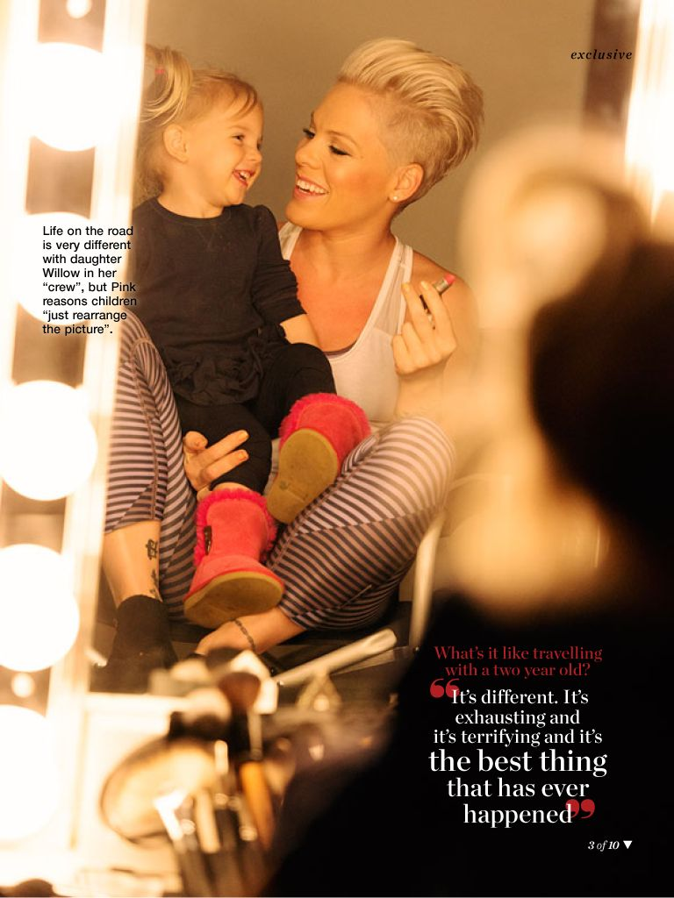
P!nk 4
P!nk 5
P!nk 6
P!nk 7
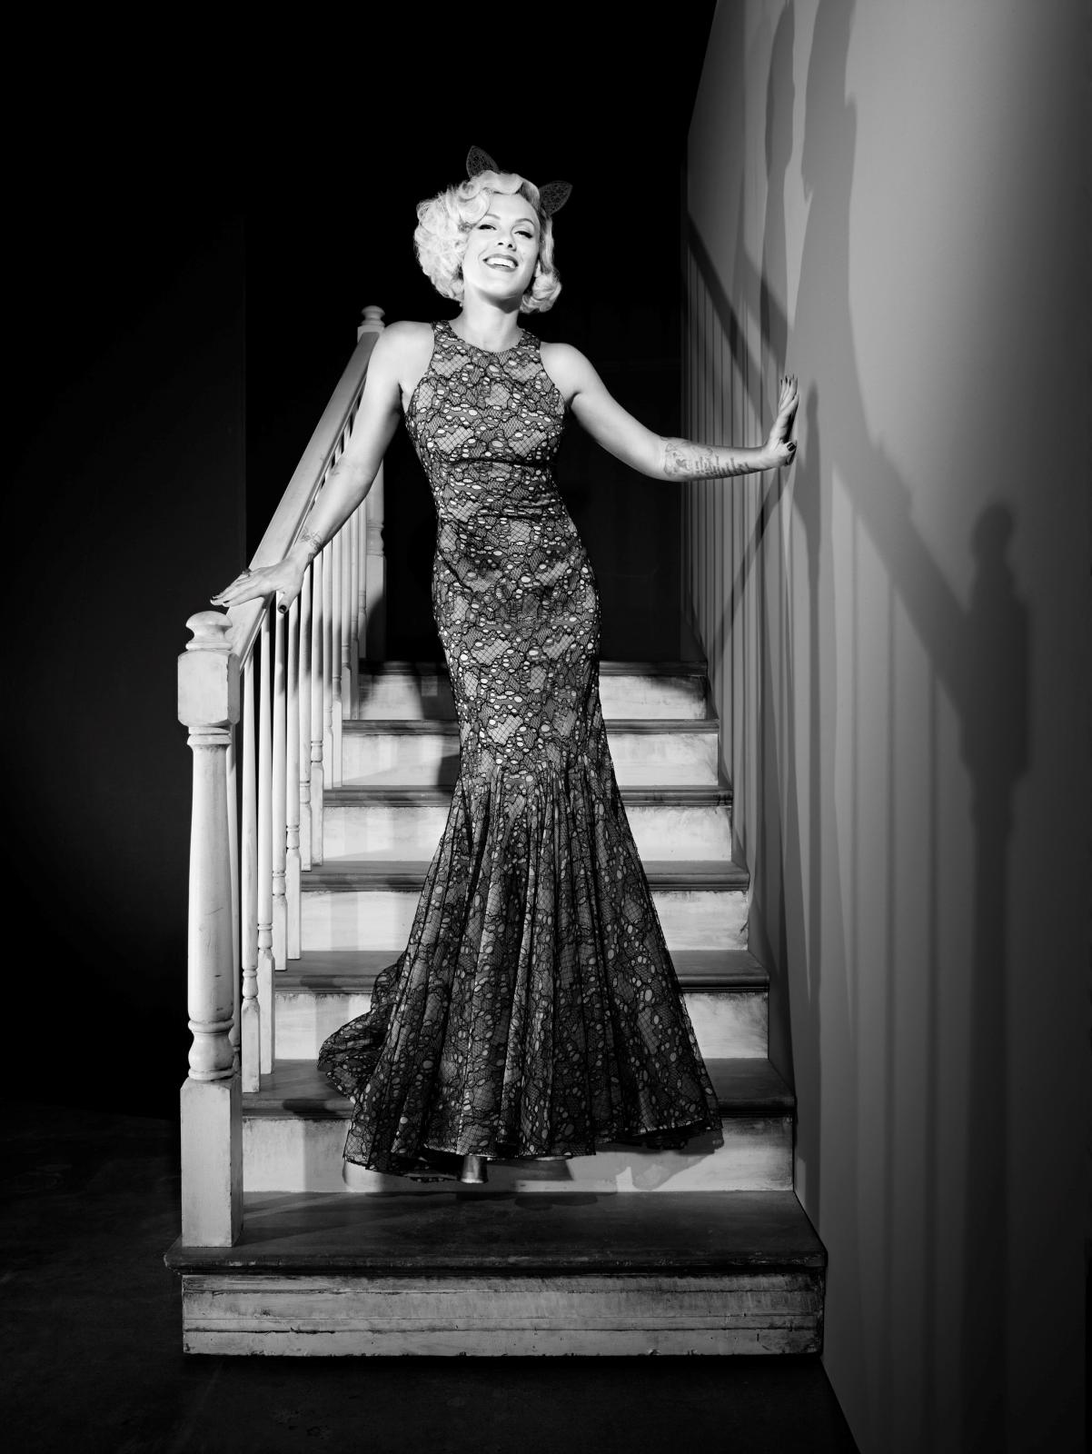
P!nk 8
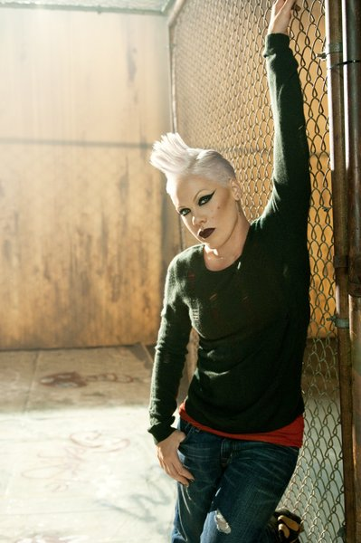
P!nk 9
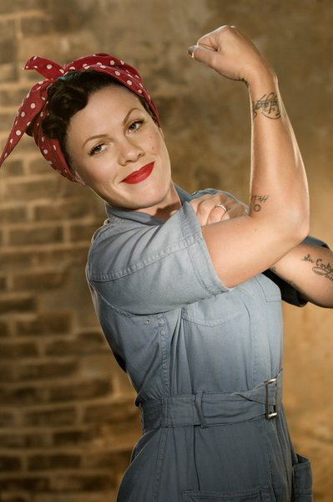
P!nk 10
P!nk 11
Bibliography
Blow Me One Last Kiss (Released on 26 Jul 2012)
https://www.youtube.com/watch?v=3jNlIGDRkvQ
Music video by P!nk performing Blow Me (One Last Kiss). (C) 2012 RCA Records, a division of Sony Music Entertainment

Brooks, A. (1997) Postfeminisms Feminism, Cultural Theory and Cultural Forms, London and New York, Routledge
Butler, J. (2010) Performative Acts and Gender Constitution: An Essay in Phenomenology and Feminist Theory, McCann, C. Kim, S. Feminist Theory Reader Local and Global Perspectives, 2nd Edition, New York, Routlege pp. 419-430
Don’t Let Me Get Me (Released on 19 Feb 2002)
https://www.youtube.com/watch?v=asaCQOZpqUQ
Music video by P!nk performing Don't Let Me Get Me. (C) 2001 Arista Records, Inc.

Family Portrait (Released on 27 Sept 2002)
https://www.youtube.com/watch?v=hSjIz8oQuko
Music video by P!nk performing Family Portrait. (C) 2001, 2002 Arista Records, Inc

Frazer, E. (1998) Feminist Political Theory, Jackson, S. Jones, J (eds) Contemporary Feminist Theories, Finland; Edinburgh University Press. pp. 50-61
Funhouse (Released on 25 Aug 2009)
https://www.youtube.com/watch?v=2ZWs50s8BvE
Music video by P!nk performing Funhouse. (C) 2009 LaFace Records, LLC

Fuckin Perfect (Released on 14 dec 2013)
https://www.youtube.com/watch?v=ocDlOD1Hw9k
Music video by P!nk performing Fuckin' Perfect. (C) 2010 LaFace Records, a unit of Sony Music

Genz, S. Brabon, B. (2009) Postfeminism Cultural Texts and Theories, Edinburgh University Press Ltd.
God Is A DJ (Released on 26 Jan 2004)
https://www.youtube.com/watch?v=XuvF7HF_kLM
Music video by P!nk performing God Is A DJ. (C) 2004 Arista Records, Inc.

Hird, M. (2002) Unidentified Pleasures: Gender Identity and It’s Failure, 8 (2), pp. 39-45
I Don’t Believe You (Released on 5 Oct 2009)
https://www.youtube.com/watch?v=26EP0ght2kI
Music video by P!nk performing I Don't Believe You. (C) 2009 RCA/JIVE Label Group, a unit of Sony Music Entertainment

Just Give Me A Reason (Released on 5 Feb 2013)
https://www.youtube.com/watch?v=OpQFFLBMEPI
Music video by P!nk featuring Nate Ruess performing Just Give Me A Reason. (C) 2012 RCA Records, a division of Sony Music Entertainment

Just Like A Pill (Released on 10 jun 2002)
https://www.youtube.com/watch?v=JDKGWaCglRM
Music video by P!nk performing Just Like A Pill. (C) 2001 Arista Records, Inc

Holtand, S. (2004) Alternative Femininities Body, Age and Identity, Oxford International Publishers Ltd.
Jackson, s. (1998) Theorising Gender and Sexuality, Jackson, S. Jones, J (eds) Contemporary Feminist Theories, Finland; Edinburgh University Press. pp. 131-143
P!nk 1- Coverlandia. (2011) P!nk – Try This, Album Cover. [Blog] Available from: http://coverlandia.blogspot.co.uk/2011/01/pnk-try-this-fanmade-album-cover.html [Accessed 15/04/15]
P!nk 2-[online image] Available from:
http://www.pinkspage.com/uk/gallery/official-pnk-photos?page=1 [Accessed 22/04/15]
P!nk 3-[online image] Available from: http://www.pinkspage.com/sites/pink/files/official_photos/051206_meyers_c_0173_v03_effect.jpg [Accessed 22/04/15]
P!nk 4-[online image] Available from: http://www.pinkspage.com/sites/pink/files/official_photos/pink_4.png [Accessed 15/04/15]
P!nk 5-[online image] Available from: http://www.pinkspage.com/sites/pink/files/official_photos/pink_16.jpg [Accessed 15/04/15]
P!nk 6-[online image] Available from: http://www.pinkspage.com/sites/pink/files/official_photos/pink_17.jpg [Accessed 15/04/15]
P!nk 7-[online image] Available from: http://www.pinkspage.com/sites/pink/files/official_photos/pink_20.jpg [Accessed 15/04/15]
P!nk 8-[online image] Available from: http://www.pinkspage.com/sites/pink/files/official_photos/pink2.jpg [Accessed 15/04/15]
P!nk 9-[online image] Available from: http://www.pinkspage.com/sites/pink/files/official_photos/RYG%20Video%20Still%20Lacey%20Terrell%201_2.jpg [Accessed 15/04/15]
P!nk 10-[online image] Available from: http://www.pinkspage.com/sites/pink/files/official_photos/RYG%20Video%20Still%20Lacey%20Terrell%202_0.jpg [Accessed 15/04/15]
P!nk 11-[online image] Available from: http://www.pinkspage.com/sites/pink/files/official_photos/pink_19.jpg [Accessed 15/04/15]
Most Girls (Released on 4 Sept 2000)
https://www.youtube.com/watch?v=UWJ_P-TdEJ0
Music video by P!nk performing Most Girls. (C) 2000 LaFace Records LLC

No Body Knows (Released on 20 Nov 2006)
https://www.youtube.com/watch?v=Z_l4pa0IkOo
Music video by P!nk performing Nobody Knows. (C) 2006 Zomba Recording, LLC
Please don’t Leave Me (Released 31 Jan 2009)
https://www.youtube.com/watch?v=q-XLvUpvjZo
Music video by P!nk performing Please Don't Leave Me.(C) 2009 LaFace Records, LLC

Raise Your Glass (Released on 6 Oct 2010)
https://www.youtube.com/watch?v=n2STDrP5UvI
Music video by P!nk performing Raise Your Glass. (C) 2010 LaFace Records, a unit of Sony Music

So What (Released on 11 Aug 2008)
https://www.youtube.com/watch?v=FJfFZqTlWrQ
Music video by P!nk performing So What. YouTube view counts pre-VEVO: 952,031 (C) 2008 LaFace Records, LLC

Sober (Released on 3 Now 2008)
https://www.youtube.com/watch?v=nJ3ZM8FDBlg
Music video by P!nk performing Sober. YouTube view counts pre-VEVO: 720,099 (C) 2008 LaFace Records, LLC

Stupid Girls (Released on 7 Feb 2006)
https://www.youtube.com/watch?v=BR4yQFZK9YM
Music video by P!nk performing Stupid Girls. (C) 2006 Zomba Recording, LLC

There You Go (Released on 8 Feb 2000)
https://www.youtube.com/watch?v=66LnhtnSoKc
Music video by P!nk performing There You Go. (C) 2000 LaFace Records LLC

Trouble (Released on 8 Sept 2003)
https://www.youtube.com/watch?v=mFu3YzRnyDU
Music video by P!nk performing Trouble. (C) 2003 Arista Records, Inc.

True Love f.t Lilly Allen (Released on 30 Jun 2013)
https://www.youtube.com/watch?v=zsmUOdmm02A
Music video by P!nk feat. Lily Allen performing True Love. (C) 2013 RCA Records, a division of Sony Music Entertainment

Try (Released on 10 Oct 2012)
https://www.youtube.com/watch?v=yTCDVfMz15M
Music video by P!nk performing Try. (C) 2012 RCA Records, a division of Sony Music Entertainment

U + UR HAND (Released on 26 Aug 2006)
https://www.youtube.com/watch?v=YUtHjOvPKT0
Music video by P!nk performing U + Ur Hand. (C) 2006 Zomba Recording, LLC

Vice, S. (1998) Psychoanalytic Feminist Theory, Jackson, S. Jones, J (eds) Contemporary Feminist Theories, Finland; Edinburgh University Press. pp. 162-175
Sinha, M. (2010) Gender and Nation, McCann, C. Kim, S. Feminist Theory Reader Local and Global Perspectives, 2nd Edition, New York, Routlege pp. 212-229
Stanley, L. Wise, S. (1993) Feminist Theory, Stanley, L. Wise, S. Breaking Out Again Feminist Ontology and Epistemology, 2nd Edition, London, Routledge.
Who Knew (Released on 18 may 2006)
https://www.youtube.com/watch?v=NJWIbIe0N90
Music video by P!nk performing Who Knew. (C) 2006 Zomba Recording, LLC

Wittig, M. (2010) One Is Not Born A Woman, McCann, C. Kim, S. Feminist Theory Reader Local and Global Perspectives, 2nd Edition, New York, Routlege pp. 244-248
You Make Me Sick (Released on 18 Dec 2000)
https://www.youtube.com/watch?v=MGfz0fv5wfQ
Music video by P!nk performing You Make Me Sick. (C) 2000 LaFace Records LLC

